Aquasphere
Water Quality Awareness And Reporting Platform
Project Submitted to the
Bharathidasan University, Tiruchirapalli-24.
in partial fulfilment of the requirements for the award of
Bachelor Degree in Computer Applications
Submitted by

NAME | REGISTER NUMBER
SUBISHA M | 23050410500112077
NITHYA SRI S | 23050410500112049
SWATHI K | 23050410500112080

Under the guidance
Ms.Viji Parthasarathy,M.S(IT).,M.C.A.,M.Phil.,Ph.D.,


Department Of Computer Applications
Shrimati Indira Gandhi College
(Affiliated To Bharathidasan University)
Nationally Accredited At “A” Grade (4th Cycle) By Naac
An Iso 9001:2015 Certified Institution
Tiruchirappalli – 620 002.
April 2026

CERTIFICATE


Ms.Viji Parthasarathy,M.S(IT).,M.C.A.,M.Phil.,Ph.D.,
Assistant Professor,
Department of Computer Applications
Shrimati Indira Gandhi College,
Tiruchirappalli-620002.

CERTIFICATE
This is to certify that the project work entitled
“AQUASPHERE – WATER QUALITY AWARENESS AND REPORTING PLATFORM”

NAME | REGISTER NUMBER
SUBISHA | 23050410500112077
NITHYASRI S | 23050410500112049
SWATHI K | 23050410500112080

is a bonafide record of the work done by the above mentioned candidates in partial fulfilment of the requirements for the award of the degree of “BACHELOR OF COMPUTER APPLICATIONS ” and has been carried out under my guidance during the Sixth semester of the Academic Year (2025-2026).

Signature of the Guide Signature of the Academic Director

ACKNOWLEDGEMENT

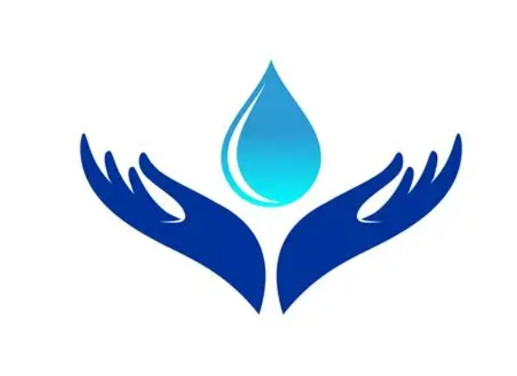

ACKNOWLEDGEMENT

First and foremost, we express our praise and thanks to Lord Almighty for his manifold blessing showered on right from admission and till the completion of the project work successfully in the temple of learning.

We endow our grateful thanks and deep sense of gratitude to our respected PRINCIPAL
Dr.Mrs.P.GAJALAKSHMI,M.Sc.,M.Phil.Ph.D., Shrimati Indira Gandhi College, Tiruchirappalli and the management for providing us all the Support carry out the project.

We express our thanks and deep sense of gratitude to our ACADEMIC DIRECTOR
Dr. S. RETHINAVALLI, MCA., M.Phil., Ph.D., of Computer Applications, Shrimati Indira Gandhi College, Tiruchirappalli for sustained Encouragement shown towards the successful completion of this work.

We express our thanks and deep sense of gratitude to our guide
MS.VIJI PARTHASARATHY,M.S(IT).,M.C.A.,M.PHIL.,(PH.D.) Assistant Professor, Department of Computer Applications, for her guidance and encouragement during the course of our study and accomplished this project successfully.

We also submitted our heartfelt thanks to our tutor MS.J.RATHNA,B.E.,M.Tech.,Assistant Professor, Department of Computer Applications, Shrimati Indira Gandhi College Tiruchirappalli for her motivation and support rendered during the tenure of our course.

Viva – Voce Examination
The Project Viva Voce Examination was held on --------------------------

Signature Of Internal Examiner Signature Of External Examiner

CONTENT
S.NO | TITLE | PAGE NO
 | ABSTRACT
1 | INTRODUCTION | 1
2 | SYSTEM ANALYSIS  - Existing System  - Proposed System | 2
3 | SYSTEM CONFIGURATION  - Hardware Specification  - Software Specification | 4
4 | PROJECT DESCRIPTION  - Software Description  - Modules Description | 5
5 | SYSTEM DESIGN  - Data Flow Diagram | 10
6 | TESTING  - Unit Testing  - Integration Testing  - System Testing | 11
7 | SOFTWARE IMPLEMENTATION  - Source Code  - Screen Layouts | 15
 | CONCLUSION | 30
 | FUTURE ENHANCEMENTS | 31
 | BIBLIOGRAPHY | 32

ABSTARCT
AQUASPHERE– Water Quality Awareness and Reporting Platform is a comprehensive, citizen-centric system developed to enhance public health, environmental sustainability, and water resource management. Access to safe and clean water is a fundamental necessity, yet many communities continue to face challenges related to water contamination caused by industrial waste, sewage leakage, chemical discharge, and poor infrastructure maintenance. Aquasphere addresses this issue by providing a digital platform that enables real-time reporting, efficient monitoring, and structured resolution of water quality problems. The platform serves as a vital bridge between public observation and authoritative action. It empowers citizens to actively participate in environmental protection by allowing them to instantly report suspected water contamination through a user-friendly web interface. Users can describe issues such as unusual water color, foul smell, unpleasant taste, or visible pollutants. The system also allows them to upload photographic evidence and provide location details, ensuring accurate identification of contamination sources. By involving the community directly, the platform promotes shared responsibility and increases awareness about water conservation and safety practices. In addition to citizen participation, Aquasphere includes a centralized NGO/Government Dashboard that acts as the administrative control center of the system. Authorized officials can access reported complaints, review detailed information, and monitor issues in a structured manner. The dashboard enables effective mapping, prioritization, and assignment of complaints to volunteers for on-site verification. This organized workflow ensures that each issue is handled systematically and transparently. The complaint lifecycle is managed through a well-defined status progression: Reported → Investigated → Action Taken → Resolved. This structured process ensures accountability at every stage, from initial reporting to final resolution. Volunteers conduct field verification and update investigation findings, while administrators oversee corrective actions and confirm resolution. Citizens can track the status of their complaints in real time, fostering trust and transparency in the system.

- INTRODUCTION
Water is one of the most vital natural resources for human survival and overall development. It is essential not only for drinking and domestic use but also for agriculture, industry, sanitation, and ecosystem balance. Access to clean and safe water is directly connected to public health, environmental sustainability, and economic growth. When water sources are safe and properly managed, communities experience improved living standards, reduced disease outbreaks, and enhanced productivity. However, in many regions, maintaining water quality continues to be a significant challenge. Water contamination occurs due to various factors such as industrial discharge, sewage leakage, improper waste disposal, chemical runoff from agricultural fields, and aging or poorly maintained infrastructure. These pollutants degrade water quality and make it unsafe for consumption and daily use. Contaminated water is a major cause of waterborne diseases including cholera, typhoid, dysentery, and hepatitis. Such diseases affect millions of people every year, especially in densely populated or underdeveloped areas where monitoring systems are weak. The health impact not only burdens families but also strains healthcare systems and hampers economic development.Traditional water quality monitoring systems mainly rely on periodic inspections conducted by government authorities or non-governmental organizations (NGOs). These inspections involve manual sample collection and laboratory testing, which are time-consuming and limited by available manpower and resources..
To overcome these challenges, AQUASPHERE – Water Quality Awareness and Reporting Platform is introduced as a citizen-centric digital solution. The platform leverages modern web technologies to enable real-time reporting and structured management of water quality issues. Citizens can actively participate by reporting suspected contamination through an easy-to-use interface. They can provide detailed descriptions of the issue, upload photographic evidence, and share location information, ensuring accurate identification of affected areas. Alongside citizen reporting, AQUASPHERE provides a centralized dashboard for NGOs and government authorities. This dashboard allows officials to monitor reported incidents, assign responsibilities, track investigation progress, and update resolution status efficiently. By integrating community participation with administrative oversight, the system ensures transparency, accountability, and faster response to water-related problems. AQUASPHERE acts as a crucial bridge between public observation and authoritative action. It creates a collaborative ecosystem where citizens, volunteers, and administrators work together toward a common goal of ensuring safe and clean water. Through structured workflows and digital tracking, the platform strengthens water quality management and contributes to building healthier communities and sustainable environmental practice.

SYSTEM ANALYSIS

EXISTING SYSTEM
In the current system of water quality management, the following methods are commonly used:
- Manual complaint submission (phone calls, office visits)
- Periodic inspections and lab testing
- Limited public participation
- No real-time tracking of complaints

DRAWBACKS:
- Delayed response
- Lack of location accuracy
- Poor transparency
- No centralized database
- Limited accountability

PROPOSED SYSTEM
The proposed system, AQUASPHERE, is a digital platform that enables real-time reporting and management of water quality issues. It connects citizens with NGOs and government authorities through a mobile application and a centralized web dashboard.

2.2.1.Citizen Mobile Application
The mobile application allows users to report water contamination easily and quickly. Citizens can capture photos of polluted water sources, automatically geotag the location using GPS, and describe issues such as unusual color, smell, or taste.
Users can track the status of their complaint through different stages:
Reported → Investigated → Action Taken → Resolved
The app also provides water awareness information and conservation tips to promote responsible water usage.

2.2.2.NGO/Government Dashboard
The web-based dashboard helps authorities manage and monitor all reported complaints efficiently. Reports are displayed on a live map for better visualization of affected areas.
Officials can filter complaints by location, severity, and status, assign field officers for investigation, and update the progress of each case. The system maintains a structured workflow to ensure proper tracking and accountability.

2.2.3.Benefits of the Proposed System
- Real-time issue reporting
- Accurate GPS-based location tracking
- Centralized complaint management
- Faster response and resolution
- Increased transparency and public participation

SYSTEM CONFIGURATION

HARDWARE SPECIFICATION

Processor : AMD PRO A4-3350B APU with Radeon R4 Graphics 2.00
Hard disk : 500 GB
RAM : 4.00 GB (3.46 GB usable)
Keyboard : Standard keyboard
Mouse : USB RTM 019 3D Optional Mouse

SOFTWARE SPECIFICATION

Operating System : Windows 11
System Type : 64-bit operating system, x64-based processor
IDE : Visual Studio Code
Front-End : HTMl, CSS and JavaScript
Back-End : Node.js
Database : MySQL
Styling : Material

4. PROJECT DESCRIPTION

SOFTWARE DESCRIPTION

HTML (HYPERTEXT MARKUP LANGUAGE)
HTML is the standard markup language used to design the structure of web pages. In the AQUASPHERE project, HTML is used to create the basic layout and structure of the website.
- Page Structure: Defines headings, forms, buttons, tables, and layout sections.
- Form Handling: Used to collect user inputs such as water issue description, location details, and login credentials.
- Semantic Elements: Improves readability and accessibility of the web application.
- Integration Support: Works seamlessly with CSS and JavaScript to create a dynamic and responsive interface.

CSS (CASCADING STYLE SHEETS)
CSS is used to style and enhance the visual appearance of the website.
- Responsive Design: Ensures the platform works properly on mobile, tablet, and desktop devices.
- UI Styling: Improves colors, fonts, spacing, and layout alignment.
- User-Friendly Interface: Provides clean and attractive design for better user experience.
- Dashboard Styling: Used to design the NGO/Government dashboard with structured layouts and visual clarity.

JAVASCRIPT
JavaScript is used to add interactivity and dynamic behavior to the website.
- Form Validation: Validates user inputs before submission.
- Dynamic Updates: Updates complaint status and content without reloading the page.
- API Handling: Sends and receives data between frontend and backend.
- Event Handling: Manages user actions such as button clicks, form submissions, and filtering reports.
- Real-Time Interaction: Enables smooth and responsive user experience.

SQLDB
SqlDB is a NoSQL database used to store and manage application data.
- Document-Oriented Database: Stores data in JSON-like format for flexibility.
- Complaint Storage: Saves user reports, images, location details, and status updates.
- Scalable Structure: Handles large volumes of water quality reports efficiently.
- Fast Data Retrieval: Enables quick fetching of reports for dashboard visualization.
  - MODULES DESCRIPTION
The AQUASPHERE – Water Quality Awareness and Reporting Platform consists of the following key modules:

• CITIZEN LOGIN MODULE:
This module allows registered citizens to securely log in to the system. New users can create an account by providing basic details such as name, email, and password.
After login, citizens can access features like reporting new water issues, viewing report history, and tracking complaint status. The module ensures secure authentication and protects user data.

• NEW REPORT SUBMISSION MODULE:
This module enables citizens to report water contamination issues in real time.
Users can:
- Enter details about the issue (color, smell, taste, visible waste, etc.)
- Upload images as evidence
- Provide location details (GPS/manual entry)
Once submitted, the report is stored in the database and assigned an initial status of “Reported.” This module acts as the core feature of the platform.

• MY REPORTS / HISTORY MODULE:
This module allows citizens to view all previously submitted complaints.
Users can:
- Track the current status of each report
- View updates made by volunteers or admins
- Monitor progress from Reported → Investigated → Action Taken → Resolved
This ensures transparency and builds trust between citizens and authorities.

• VOLUNTEER LOGIN MODULE:
Volunteers can log in to the system to view assigned complaints.
They can:
- Check report details and location
- Update investigation findings
- Change complaint status after field verification
This module helps in ground-level issue verification and supports faster resolution.

• ADMIN LOGIN MODULE:
The Admin module acts as the central management system.
Admins can:
- View all submitted complaints
- Assign reports to volunteers
- Monitor complaint status
- Update progress and mark issues as resolved
- Manage user accounts
This module ensures proper workflow management, accountability, and efficient monitoring of water quality issues.

4.3 WORKFLOW OF THE SYSTEM
- The user visits the AQUASPHERE website, where the homepage displays general information about the platform, including Home, role descriptions (Citizen and Volunteer), awareness content, and a Login option.
- When the user clicks the Login button, three login options are provided: Citizen Login, Volunteer Login, and Admin Login. Based on the selected role and valid credentials, the user is redirected to the respective dashboard.
- After logging in as a Citizen, the user can access the dashboard and raise a new water issue by entering details such as type of contamination, description of the problem, and uploading image evidence. The complaint is stored in the database with the status marked as “Reported.” Citizens can also view their complaint history and track progress.
- After logging in as a Volunteer, the user can view reported issues assigned or available for verification. The volunteer reviews complaint details, checks the location, conducts field verification, and updates the complaint status to “Investigated.”
- After logging in as an Admin (NGO authority), the admin can view all complaints, assign issues to volunteers, monitor progress, and initiate corrective actions. Once the issue is resolved, the status is updated to “Action Taken” or “Resolved.”
- Each complaint follows a structured lifecycle:
Reported → Investigated → Action Taken → Resolved, ensuring transparency, accountability, and proper coordination among all users.

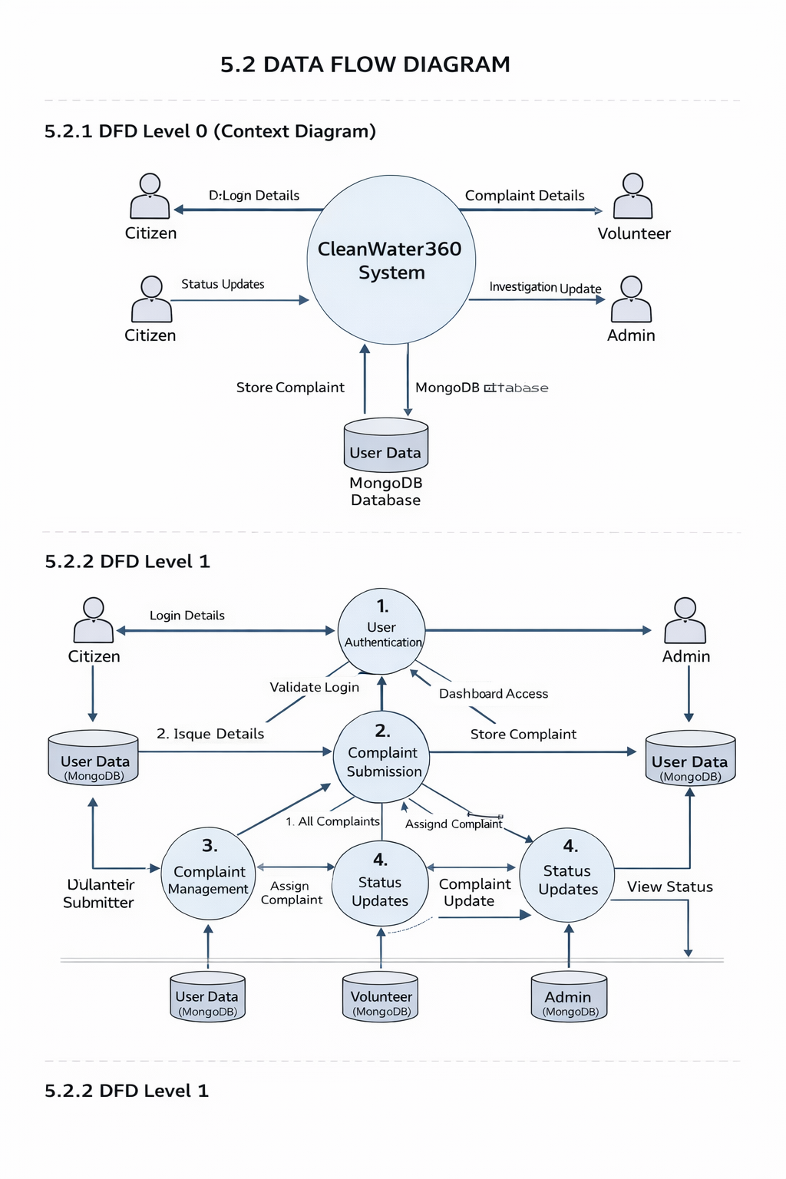
SYSTEM DESIGN

Figure 5.2 Data Flow diagram for overall syste

Figure 5.2 illustrates the Data Flow Diagram (DFD) for the AQUASPHERE system. The system receives inputs from different users such as citizens, volunteers, and admin. Citizens provide login details and water issue reports including description and image evidence. These inputs are processed through authentication and complaint management modules, where the data is stored in the SqlDB database.Volunteers access assigned complaints, update investigation details, and modify the complaint status. The admin monitors all reports, assigns tasks to volunteers, and updates the final resolution status. The system processes these data flows in a structured manner and provides status updates back to the respective users, ensuring proper tracking and management of water quality issues.

6. TESTING
Software testing plays an important role in identifying errors and improving the quality of the system. After designing and coding the AQUASPHERE system using HTML, CSS, JavaScript, and SqlDB, testing was performed to ensure that all modules function correctly.
Testing ensures that user authentication, complaint submission, status updates, and dashboard operations work efficiently without errors. In system testing, the complete functionality of the platform is verified after integration of all modules.

6.1 UNIT TESTING
Unit testing is performed to test individual components or modules of the AQUASPHERE system. Each module is tested separately to ensure it performs as expected.
The test cases focus on core functionalities such as login validation, complaint submission, status tracking, and complaint assignment.

Test Case – 1

Field | Description
Name of the Test | Login Authentication
Sample Input | Valid username and password
Expected Output | User redirected to respective dashboard
Actual Output | Same as expected output
Remark | Successful
Table 6.1: Unit Testing for Login Authentication
Table 6.1 illustrates the testing of the login module. The system correctly validates user credentials and redirects to the appropriate dashboard. The test has been conducted successfully.

Test Case – 2

Field | Description
Name of the Test | Complaint Submission
Sample Input | Issue description + image upload
Expected Output | Complaint stored in database with status “Reported”
Actual Output | Same as expected output
Remark | Successful
Table 6.2: Unit Testing for Complaint Submission
Table 6.2 illustrates the testing of complaint submission. The system successfully stores complaint details in the SqlDB database with the initial status set as “Reported.”

Test Case – 3
Field | Description
Name of the Test | Complaint Assignment
Sample Input | Admin assigns complaint to volunteer
Expected Output | Complaint updated with assigned volunteer details
Actual Output | Same as expected output
Remark | Successful
Table 6.3: Unit Testing for Complaint Assignment
Table 6.3 illustrates the testing of the complaint assignment module. The admin successfully assigns the issue, and the updated information is reflected in the system.

Test Case – 4
Field | Description
Name of the Test | Status Update by Volunteer
Sample Input | Volunteer updates status to “Investigated”
Expected Output | Complaint status updated in database
Actual Output | Same as expected output
Remark | Successful
Table 6.4: Unit Testing for Status Update
Table 6.4 illustrates the testing of status update functionality. The system correctly updates and stores the complaint status.

Test Case – 5
Field | Description
Name of the Test | Complaint Tracking (Citizen View)
Sample Input | Citizen views “My Reports”
Expected Output | Updated complaint status displayed correctly
Actual Output | Same as expected output
Remark | Successful
Table 6.5: Unit Testing for Complaint Tracking
Table 6.5 illustrates the testing of the complaint tracking module. Citizens can view real-time updates of their submitted complaints successfully.

6.3 INTEGRATION TESTING
Integration testing is performed to verify that different modules of the AQUASPHERE system work together correctly after integration. It focuses on testing the interaction between frontend, backend, and database.

Integration Test Case – 1
Field | Description
Name of the Test | Frontend and Database Integration
Sample Input | Citizen submits complaint form
Expected Output | Complaint data stored successfully in database
Actual Output | Same as expected output
Remark | Successful
Table 6.3: Integration Testing for Complaint Data Storage
Table 6.3 shows that complaint data is successfully inserted and retrieved from the database.

Integration Test Case – 2
Field | Description
Name of the Test | Admin–Volunteer Module Integration
Sample Input | Admin assigns complaint to volunteer
Expected Output | Assigned complaint visible in volunteer dashboard
Actual Output | Same as expected output
Remark | Successful
Table 6.4: Integration Testing for Complaint Assignment Flow
Table 6.4 shows that complaint assignment is properly reflected across dashboards.

6.2 SYSTEM TESTING
System testing is performed to evaluate the complete and integrated AQUASPHERE application. In this stage, the entire system is tested as a whole to ensure that all modules work together properly and meet the project requirements.
The objective of system testing is to verify end-to-end functionality, including user authentication, complaint submission, complaint assignment, status updates, and complaint tracking.

System Test Case – 1
Field | Description
Name of the Test | End-to-End Complaint Workflow
Sample Input | Citizen submits complaint → Admin assigns → Volunteer updates → Admin resolves
Expected Output | Complaint status moves from “Reported” to “Resolved”
Actual Output | Same as expected output
Remark | Successful
Table 6.1: System Testing for Complete Complaint Lifecycle
Table 6.1 shows that the complaint successfully passes through all stages without errors.

System Test Case – 2
Field | Description
Name of the Test | Multi-User Role Access
Sample Input | Login using Citizen, Volunteer, and Admin accounts
Expected Output | Each user accesses only their respective dashboard
Actual Output | Same as expected output
Remark | Successful
Table 6.2: System Testing for Role-Based Access Control
Table 6.2 shows that the system correctly restricts access based on user roles.System testing confirms that the AQUASPHERE platform performs reliably and ensures smooth coordination among users.

7.SOFTWARE IMPLEMENTATION

7.1 SOURCE CODE

Index.html

<!DOCTYPE html>
<html lang="en">

<head>
<meta charset="UTF-8">
<meta name="viewport" content="width=device-width, initial-scale=1.0">
<title>AQUASPHERE - Clean Water for Everyone</title>
<link rel="stylesheet" href="styles.css">
<link href="https://fonts.googleapis.com/css2?family=Inter:wght@400;500;600;700;800&display=swap" rel="stylesheet">
<!-- Using Phosphor Icons as a lightweight alternative to Lucide for static usage -->
<script src="https://unpkg.com/@phosphor-icons/web"></script>
</head>

<body>
<!-- Navigation -->
<nav class="navbar">
<div class="container nav-container">
<a href="index.html" class="logo">
<i class="ph-fill ph-drop"></i>
AQUASPHERE
</a>

<button class="menu-toggle" aria-label="Toggle Menu" aria-expanded="false">
<i class="ph ph-list"></i>
</button>
<ul class="nav-links">
<li><a href="#home" class="nav-link active">Home</a></li>
<li><a href="#citizen" class="nav-link">Citizen</a></li>
<li><a href="#volunteer" class="nav-link">Volunteer</a></li>
<li><a href="#admin" class="nav-link">Admin</a></li>
<li><a href="login.html" class="btn btn-primary">Login</a></li>

<li>
<button class="theme-toggle" aria-label="Toggle Theme">
<i class="ph-fill ph-moon"></i>
</button>
</li>
</ul>
</div>
</nav>

<!-- Hero Section -->
<!-- Hero Section -->
<!-- Hero Section -->
<section id="home" class="hero"
style="background-image: url('Assets/images/hero-bg.jpg'); background-size: cover; background-position: center;">
<div class="container animate-on-scroll"
style="display: flex; align-items: center; gap: 3rem; flex-wrap: wrap;">
<div
style="background-color: var(--hero-box-bg); padding: 3rem; border-radius: var(--radius-lg); backdrop-filter: blur(4px); flex: 1; min-width: 300px;">
<h1 class="hero-title hero-text-enhanced">Empowering Citizens for<br>Cleaner Water
</h1>
<p class="hero-subtitle hero-text-enhanced">
Join the AQUASPHERE initiative. Report water quality issues, track improvements, and contribute
to a
safer environment for your community.
</p>
<div class="hero-buttons">
<a href="#citizen" class="btn btn-primary">
Get Started <i class="ph ph-arrow-down"></i>
</a>
<a href="about.html" class="btn btn-outline">
Learn More
</a>

</div>
</div>
<div style="flex: 1; min-width: 300px; display: flex; justify-content: center;">
<img src="Assets/images/monitoring.jpg" alt="Water Quality Monitoring"
style="width: 100%; max-width: 500px; border-radius: var(--radius-lg); box-shadow: 0 20px 25px -5px rgba(0, 0, 0, 0.3), 0 10px 10px -5px rgba(0, 0, 0, 0.2); border: 4px solid rgba(255, 255, 255, 0.2);">
</div>
</div>
</section>

<!-- Impact Stats -->
<!-- Impact Stats -->
<section class="stats-section"
style="background-color: var(--stats-bg); color: var(--white); padding: 4rem 1.5rem;">
<div class="container animate-on-scroll"
style="display: flex; justify-content: space-around; flex-wrap: wrap; gap: 2rem; text-align: center;">
<div>
<h2 style="font-size: 3rem; font-weight: 800; color: var(--secondary-color);"><span
class="counter-value" data-target="5000" data-suffix="+">0</span></h2>
<p style="opacity: 0.9; font-size: 1.1rem; color: white;">Issues Reported</p>
</div>
<div>
<h2 style="font-size: 3rem; font-weight: 800; color: var(--secondary-color);"><span
class="counter-value" data-target="1200" data-suffix="">0</span></h2>
<p style="opacity: 0.9; font-size: 1.1rem; color: white;">Communities Helped</p>
</div>
<div>
<h2 style="font-size: 3rem; font-weight: 800; color: var(--secondary-color);"><span
class="counter-value" data-target="98" data-suffix="%">0</span></h2>
<p style="opacity: 0.9; font-size: 1.1rem; color: white;">Resolution Rate</p>
</div>
</body>
</html>

Style.css:

:root {
/* Premium Brand Colors */
--primary-color: #0f172a;
/* Deep Royal Blue/Slate */
--primary-hover: #1e293b;
--secondary-color: #0ea5e9;
/* Radiant Sky Blue */
--secondary-hover: #0284c7;
--accent-color: #38bdf8;
/* Light Sky Blue */

--text-dark: #1e293b;
--text-light: #64748b;
--white: #ffffff;
--bg-light: #f1f5f9;
--bg-gradient: linear-gradient(135deg, #f1f5f9 0%, #cbd5e1 100%);

--glass-bg: rgba(255, 255, 255, 0.95);
--glass-border: rgba(255, 255, 255, 0.5);

/* Spacing & Layout */
--container-width: 1280px;
--header-height: 80px;
--radius-sm: 8px;
--radius-lg: 24px;

/* Premium Shadows */
--shadow-sm: 0 4px 6px -1px rgba(0, 0, 0, 0.05), 0 2px 4px -1px rgba(0, 0, 0, 0.03);
--shadow-md: 0 10px 15px -3px rgba(0, 0, 0, 0.05), 0 4px 6px -2px rgba(0, 0, 0, 0.03);
--shadow-lg: 0 25px 50px -12px rgba(0, 0, 0, 0.15);
--shadow-blue: 0 10px 15px -3px rgba(14, 165, 233, 0.2);

/* Transitions */
--transition: all 0.4s cubic-bezier(0.4, 0, 0.2, 1);

/* Dark Mode Variables */
--bg-dark: #0f172a;
--bg-card-dark: #1e293b;
--text-main-dark: #f1f5f9;
--text-muted-dark: #94a3b8;
--border-dark: #334155;

/* Semantic Theme Variables */
--hero-box-bg: rgba(127, 255, 212, 0.8);
--pill-citizen-bg: #e0f2fe;
--pill-citizen-text: #0284c7;
--pill-volunteer-bg: #d1fae5;
--pill-volunteer-text: #059669;
--pill-admin-bg: #fee2e2;
--pill-admin-text: #dc2626;
--card-bg: var(--white);
--section-bg-alt: var(--bg-light);
--stats-bg: var(--primary-color);

/* Fixed Colors (Theme-Independent) */
--white-fixed: #ffffff;
--dark-fixed: #0f172a;
}

[data-theme="dark"] {
--bg-light: var(--bg-dark);
--white: var(--bg-card-dark);
--text-dark: var(--text-main-dark);
--text-light: var(--text-muted-dark);
--secondary-color: #38bdf8;
/* Brighter Sky Blue for Dark Theme */
--primary-color: #7dd3fc;
/* Light cyan for primary actions in dark mode */
--glass-bg: rgba(31, 41, 55, 0.9);

--shadow-sm: 0 1px 2px 0 rgba(0, 0, 0, 0.5);
--shadow-md: 0 4px 6px -1px rgba(0, 0, 0, 0.5);
--shadow-lg: 0 10px 15px -3px rgba(0, 0, 0, 0.5);

/* Dark mode overrides */
--hero-box-bg: rgba(30, 41, 59, 0.9);
--pill-citizen-bg: rgba(14, 165, 233, 0.2);
--pill-citizen-text: #7dd3fc;
--pill-volunteer-bg: rgba(16, 185, 129, 0.2);
--pill-volunteer-text: #6ee7b7;
--pill-admin-bg: rgba(239, 68, 68, 0.2);
--pill-admin-text: #fca5a5;
--card-bg: var(--bg-card-dark);
--section-bg-alt: #111827;
--stats-bg: #1e293b;
/* Slightly lighter than body bg */
}

/* Dark mode hero overlay removal */
[data-theme="dark"] .hero {
background-color: var(--bg-dark);
position: relative;
}

[data-theme="dark"] .hero::before {
content: '';
position: absolute;
top: 0;
left: 0;
right: 0;
bottom: 0;
background: rgba(15, 23, 42, 0.7);
/* Dark overlay for visibility */
z-index: 1;
}

.auth-icon {
width: 64px;
height: 64px;
background-color: #e0f2fe;
color: var(--primary-color);
border-radius: 50%;
display: flex;
align-items: center;
justify-content: center;
margin-bottom: 1.5rem;
}

.auth-title {
font-size: 1.5rem;
font-weight: 700;

}

7.2 SCREEN LAYOUTS
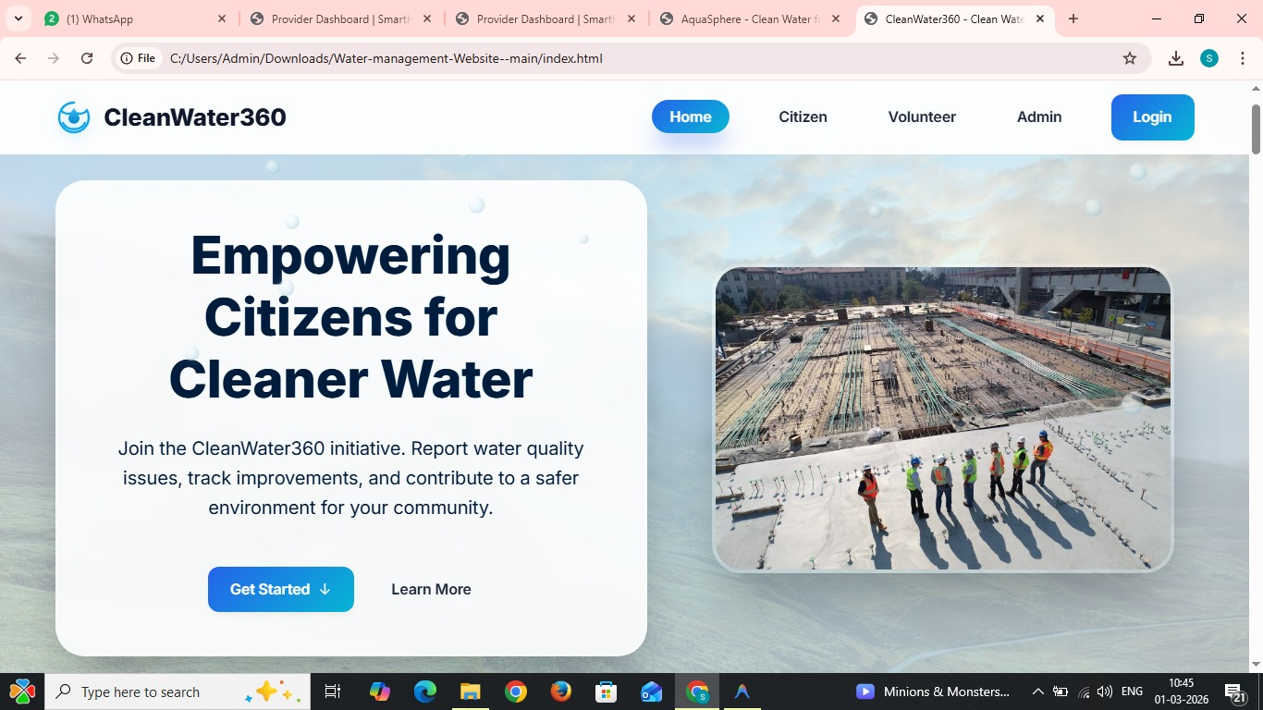

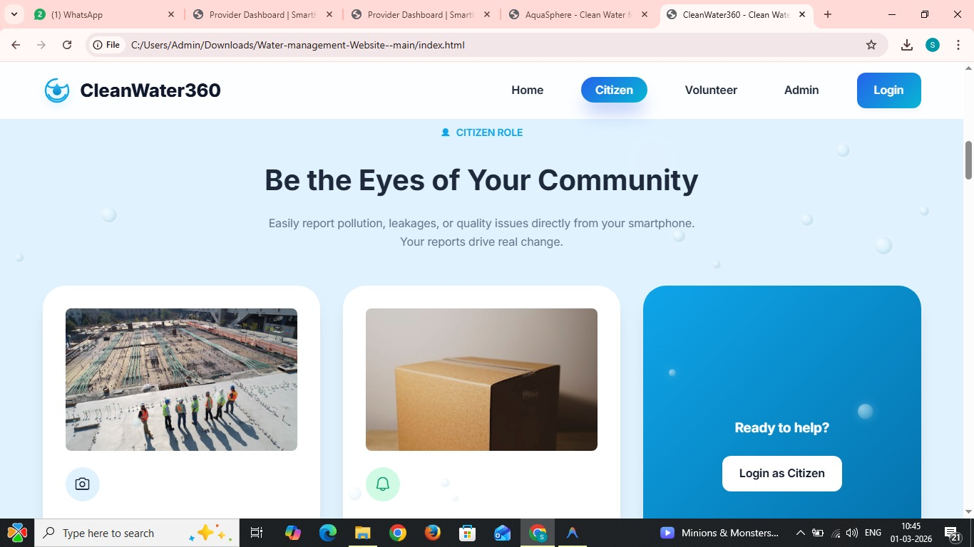

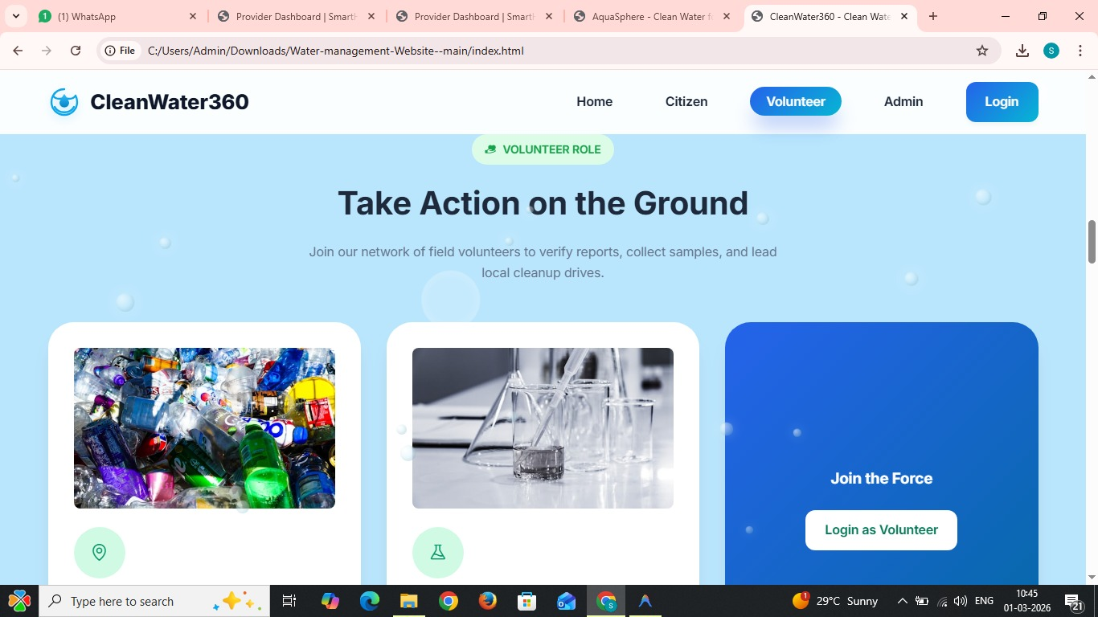

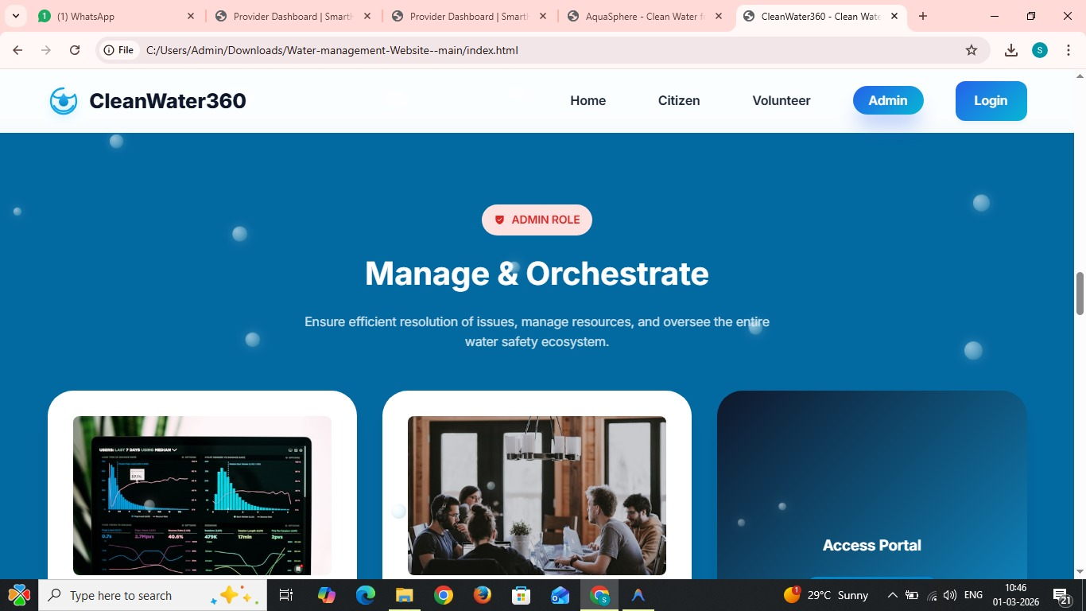

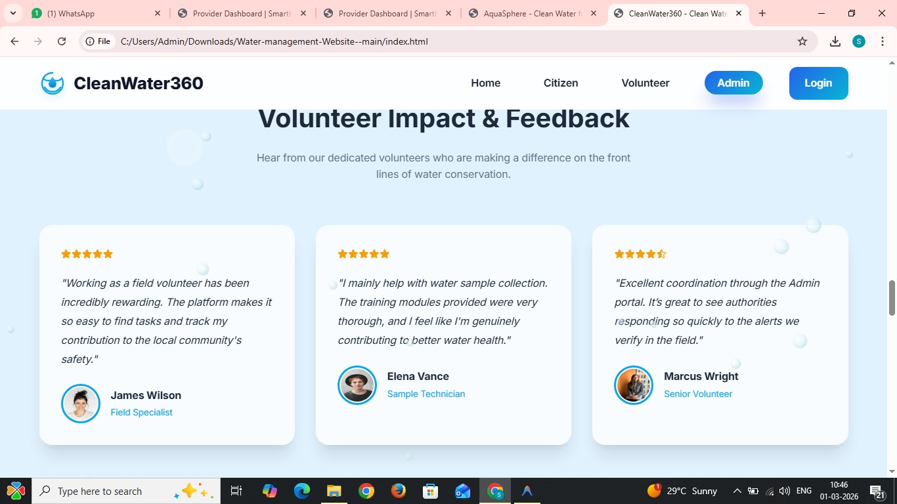

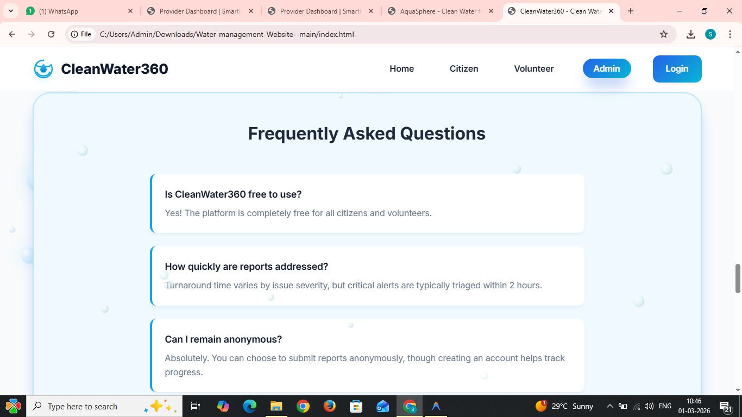
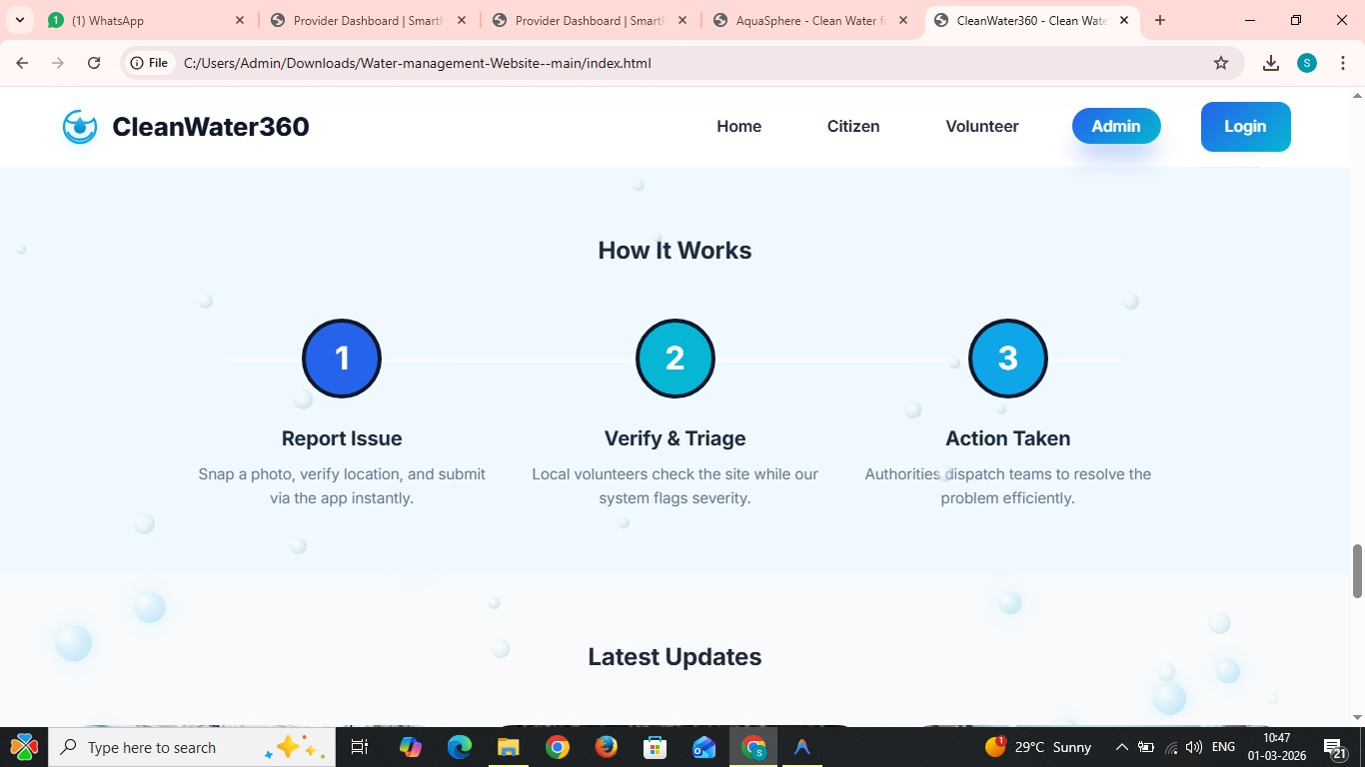

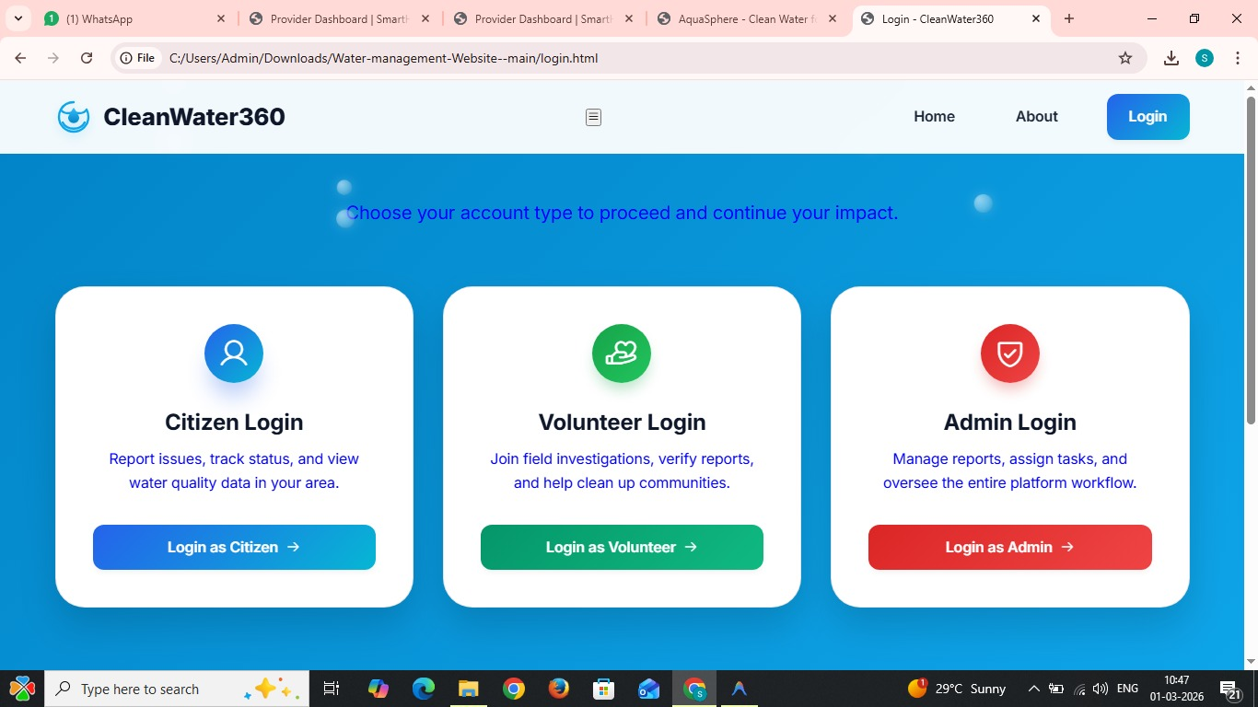

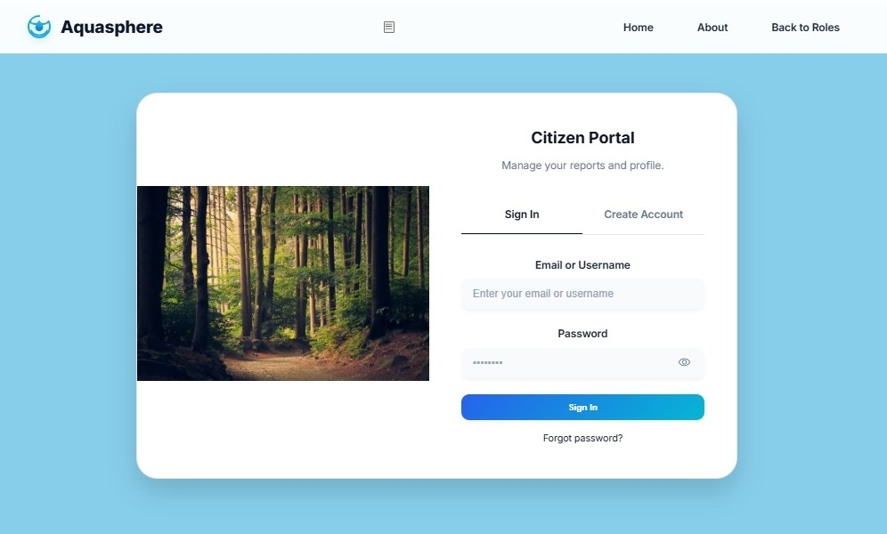

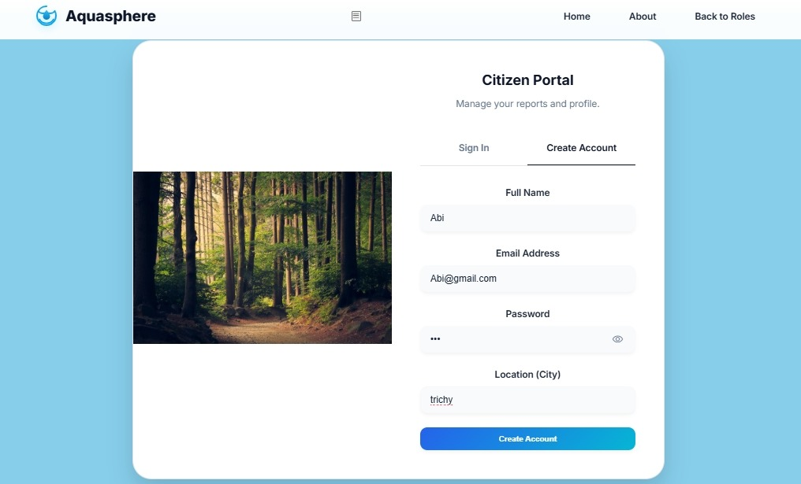

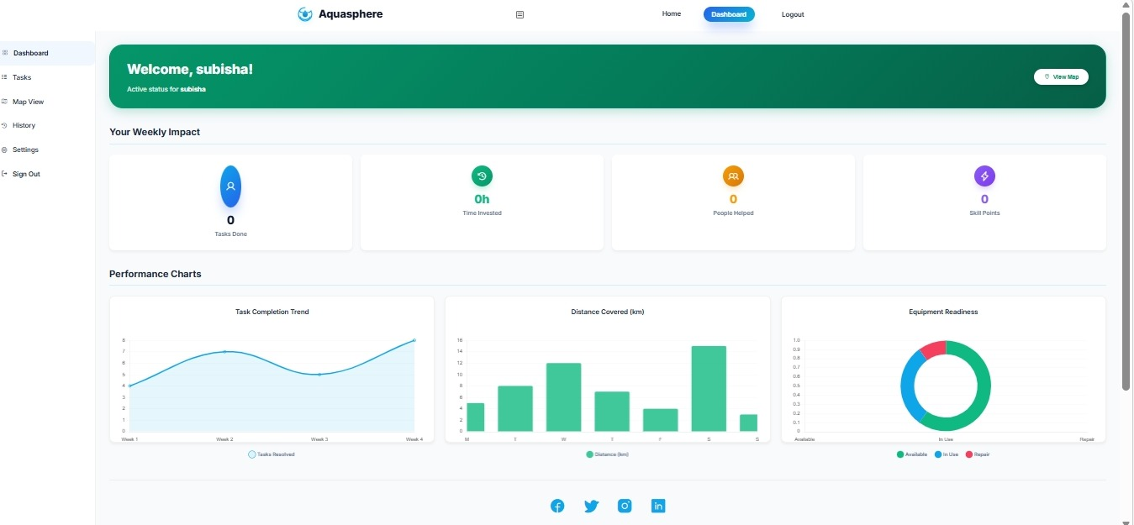

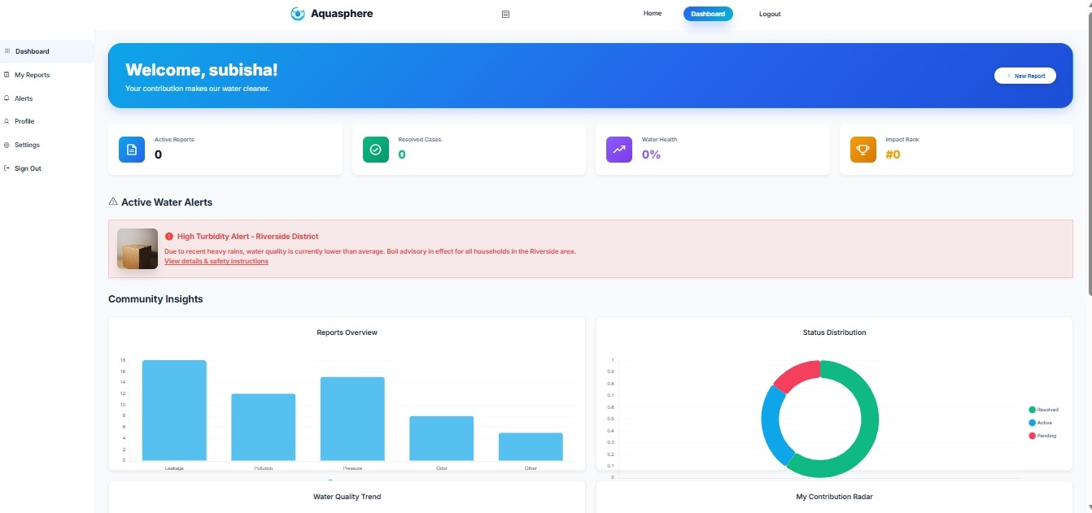

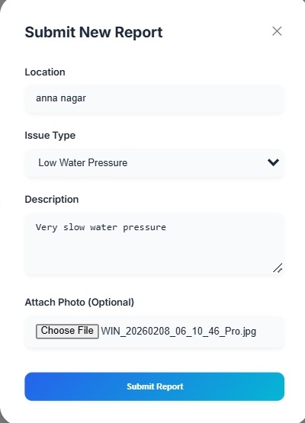

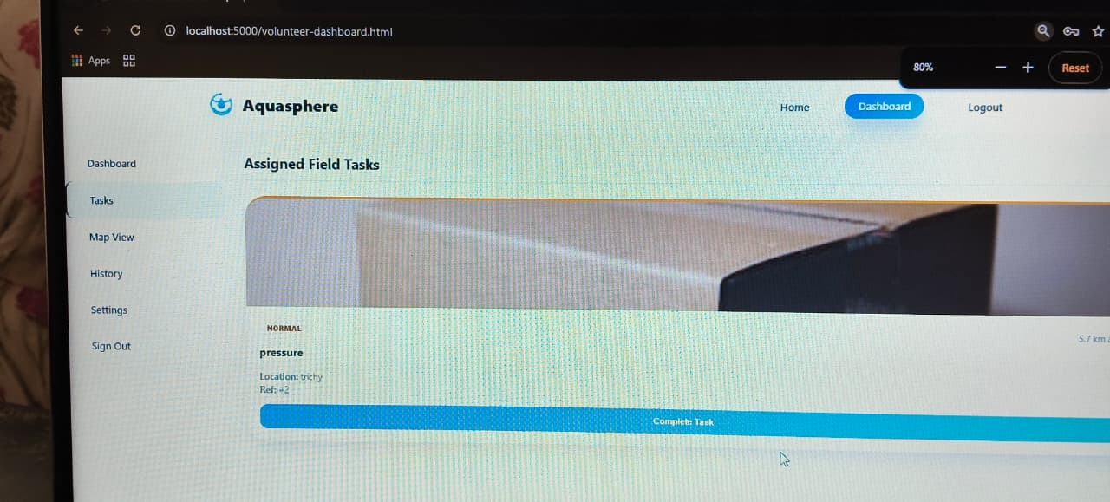
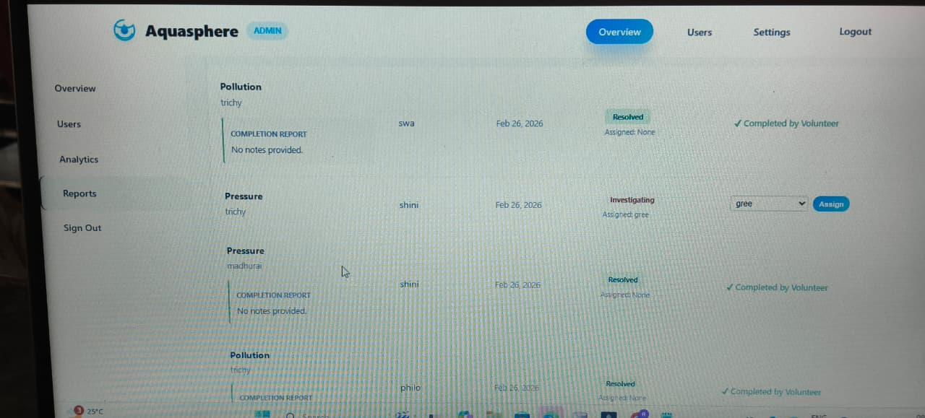

CONCLUSION
AQUASPHERE – Water Quality Awareness and Reporting Platform is a citizen-centric web application designed to improve water quality monitoring and management. The system successfully connects citizens, volunteers, and NGO administrators through a centralized digital platform.
By enabling real-time issue reporting, structured complaint tracking, and role-based dashboards, the system ensures transparency, accountability, and faster response to water contamination problems. The use of HTML, CSS, JavaScript, and SqlDB provides a simple yet effective solution for managing water-related complaints efficiently.
Overall, the project demonstrates how technology can empower communities, support environmental protection, and enhance public health through collaborative digital systems.

FUTURE ENHANCEMENTS

The AQUASPHERE system can be further enhanced by developing a dedicated mobile application for Android and iOS platforms to improve accessibility and user engagement. Integrating real-time GPS auto-detection would enable precise location tracking during water quality reporting. The system can be strengthened with AI-based water image analysis to automatically detect contamination from uploaded images. Implementing an SMS and email notification system would provide users with timely status updates. Integration with government water quality APIs can ensure accurate and reliable data exchange. A live analytics dashboard with graphical data visualization would help monitor trends and generate insights effectively. Adding multilingual support would make the platform accessible to a wider audience. Role-based performance tracking can improve volunteer accountability and management. Cloud deployment would enhance scalability, security, and system performance. Furthermore, integrating IoT-based water quality sensors would allow real-time monitoring and automated data collection. Overall, these enhancements would significantly improve efficiency, automation, and large-scale usability of the AQUASPHERE system.

BIBLIOGRAPHY
- Pressman, R. S., Software Engineering: A Practitioner’s Approach, McGraw-Hill Education.
- Sommerville, I., Software Engineering, Pearson Education.
- SqlDB Documentation, SqlDB Inc.
- W3Schools, Web Development Tutorials.
- Mozilla Developer Network (MDN), Web Technology Documentation.

WEB REFERENCES
- https://www.w3schools.com
- https://developer.mozilla.org
- https://www.sqldb.com/docs
- https://www.geeksforgeeks.org
- https://www.tutorialspoint.com

